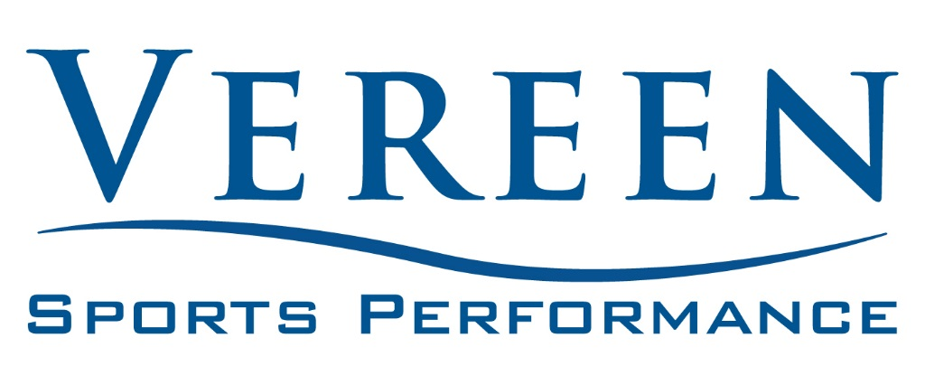

SwingFit Golf Fitness

**CASH PAY**

Initial Evaluation $150

Training Single Session $75

Training 4-Session Package $250