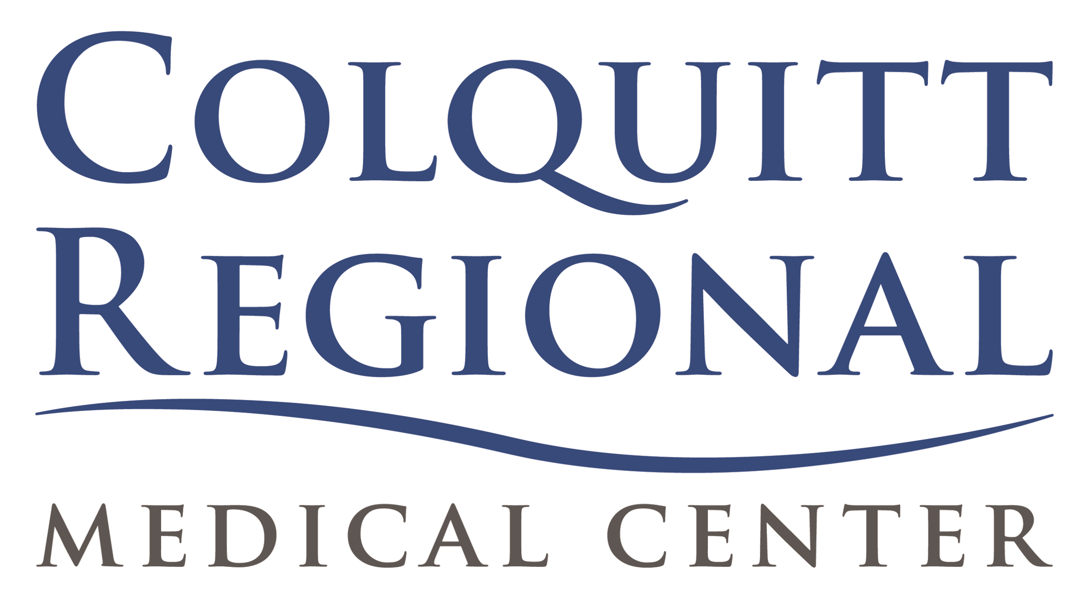

Colquitt Regional Medical Center
Healthcare Scholarship Program

Colquitt Regional Medical Center offers individual scholarships to students currently enrolled in approved healthcare programs.

Scholarships awarded will be based on the anticipated need for future positions available.
The scholarship awarded will be for $10,000 to be disbursed in four payments of $2,500 per semester to be applied to the last two years of education. Monies will be distributed to the student. Tuition and fees paid to the school must be paid by the student.

Individuals applying for a scholarship through Colquitt Regional Medical Center must agree to meet the following criteria prior to consideration:

- Applicants must complete and submit a scholarship application to Colquitt Regional Medical Center along with a letter of acceptance from an accredited college or technical school and the most recent transcript of grades.

- Students should be within 2 years of completing their degree.

- A copy of grades will be provided at the end of each semester. Students must maintain a “C” or 2.0 GPA in order to keep scholarship.

- An agreement (contract) will be entered into with the approved recipient agreeing to work for Colquitt Regional Medical Center upon graduation. The recipient will work for 3 years as repayment of educational assistance received.

- Scholarship recipients failing to work at Colquitt Regional Medical Center for the designated period will be held responsible for repayment as follows:

- If the recipient chooses to work elsewhere, repayment in the amount of triple damages will be due within 30 days of graduation.
- If an employee separates during repayment period, the amount owed is subject to triple damages will be due within 30 days of separation.

Colquitt Regional Medical Center
P.O. Box 40
3131 South Main Street

Moultrie, GA 31768
Human Resources Dept. 229-891-9478

Application for Colquitt Regional Scholarship

Applicant Information:

Full Name: ____________________________________________________________________
Email Address: _________________________________________________________________
Address: ______________________________________________________________________
Telephone: _______________________________________
City: _________________________________________________ State: __________
Zip Code: _____________________________

Educational Information:

School where applicant has been accepted: ___________________________________
Program of Study: _______________________________________________________
Grade Point Average: _________________
Anticipated Graduation Date: _______________________

Honors Received: __________________________________________________________________________________________________________________________________________________________________________________________________________________________________________

Procedure:

- Submit one reference letter from each of the following: Medical, Educational, Community and/or Employer.
- Submit a copy of the following; all college transcripts, and a letter of acceptance into approved Healthcare program.
- Write a brief essay telling about yourself, your goals, and your plans for the future.
- Interview with Scholarship Committee.

_________________________________________ ________________________________
Signature of Applicant Date
HEALTHCARE SCHOLARSHIP PROGRAM
AGREEMENT

This Healthcare Scholarship Program Agreement (this “Agreement”) is made and entered into this the ______ day of ___________________, 20___, by and between the Hospital Authority of Colquitt County d/b/a Colquitt Regional Medical Center (“Hospital”) and ________________________ (“Student”)

WHEREAS, Hospital values its employees and desires for each employee to develop and advance their learning and education;

WHEREAS, as an incentive to employees to develop and advance such education, Hospital provides certain benefits to aid employees in such development.

NOW THEREFORE, for and in consideration of the premises, and other good and valuable consideration, the receipt and sufficiency of which is hereby acknowledged, the parties hereto, intending to be legally bound, hereby agree as follows:

1. Qualification. The Student must desire to obtain further education in a designated healthcare field approved by Hospital’s Administration and deemed by it to be of benefit to Hospital, and has been approved by Administration for participation in the Colquitt Regional Medical Center Tuition Reimbursement Program. An employee must be within two years of completing the approved course of study to qualify for the Program.

2. The Program. Hospital has awarded Student the amount of $10,000.00 to be disbursed in four payments of $2,500.00 directly to Student for each semester for the last two years of Student’s education in the approved healthcare field. This program applies only to courses needed to fulfill the requirements of the Student's approved course of study.

3. Student Obligations.

3.1 Student will pay the tuition for the approved course of study and maintain a grade of “C” or better in each course.

3.2 Student may continue in the program so long as he or she is making satisfactory progress toward a degree. Satisfactory progress includes maintaining a cumulative average grade of "C" or better. Should Hospital find progress to be unacceptable, it shall immediately notify Student and Student shall repay to Hospital all prior scholarship funds paid to Student within 30 days of such notification.

3.3 In the event Student becomes unable to obtain a professional license, if applicable, due to criminal charges, or otherwise, Student shall repay to Hospital all prior scholarship funds paid to Student within 30 days of knowledge of such circumstance.

3.4 Upon completion of the course of study, Student agrees to work at Hospital as a full-time employee for a period of 36 months. Hospital shall forgive 1/36th of the benefit each for each month of employment after completion of the course of study. The first such continued employment obligation period shall begin in the month following Student’s completion of such course of study.

In the event Student does not commence employment upon completion of the course of study or terminates his or her employment at Hospital without cause or is terminated by Hospital for cause, prior to the expiration of the repayment period, Student stall repay Hospital three (3) times the full amount of the benefit provided to Student hereunder, along with any sums due as attorney's fees if collected by or through an attorney at law. Repayment of all amounts shall be due within thirty days of the date of graduation or employment termination with Hospital. If, following completion by Student of approved course of study, Hospital does not have a position available in the desired field of Student, Student may continue to work at Hospital in either the Student's current position or any other position for which the Student is qualified and hired for, in order to complete Student's obligation. If Student chooses not to do so and terminates his or her employment with Hospital without cause, including to work in his or her desired field elsewhere, Student will be obligated to repay Hospital as indicated above. Hospital agrees to give consideration to physical impairment of Student, requirement of involuntary military service or other matters beyond the control of Student or Hospital which interrupt or interfere with Student's ability to meet this requirement, provided Student resumes and completes the required employment service as soon as he or she is able to do so.

In witness whereof, the parties hereto, hereby execute and deliver this Agreement on the date first written above.

Student:

Name:

Colquitt Regional Medical Center:

Notary Public (SEAL) By:

